

# **PROJECT REPORT**

**IN**

**DEPARTMENT**

**ON**

**PROJECT/WORK ASSIGNED**

**SUBMITTED IN PARTIAL FULFILLMENT OF THE DEGREE**

**OF**

**BE(CSE)**

**Under the Guidance of Submitted By:**

**Ujjwal Singh: 211981280**

**Dr. Sandeep Rana Bishal Mandal: 2111981289**

**Department of Computer Science**

**Engineering**

**Chitkara University, Himachal Pradesh, India**

# CONTENTS

Title Page No.

|  |  |
| --- | --- |
| 1. Declaration | 3 |
| 2. Acknowledgement | 4 |
| 3. List of Figures and Tables | 5 |
| 4. Introduction | 6 |
| 4. I Project Category | 6 |
| 5. Abstract | 7 |
| 6. Work Done | **7** |
| 6.1 Overview | 8 |
| 6.2 Purpose | 8 |
| 6.4 External Interface Requirements | 10 |
| 6.5 System Features | 10 |
|  |  |
| 7. Conclusion and Future Scope | 16 |
| 7.1 Conclusion | 16 |
| 7.2 Future Scope | 16 |
| 8. Snapshots | 17 |
| 9.Coding | 21 |
|  |  |

## **DECLARATION**

We hereby declare that the project work titled, **"Chat Application"** submitted as part of Bachelor' s degree in CSE, at Chitkara University, Himachal Pradesh, is an authentic record of our own work carried out under the supervision of Dr**. Sandeep Rana**.

**Signature(s):**

**-------------------------**

### **ACKNOWLEDGEMENT**

We have taken efforts in this project. However, it would not have been possible without the kind support and help of many individuals and organizations. We would like to extend our sincere thanks to all of them.

We are highly indebted to Dr. **Sandeep Rana** for their guidance and constant supervision as well as for providing necessary" information regarding the project & also for their support in completing the project.

We would like to express our gratitude towards our parents & member of CSE Department for their kind co-operation and encouragement which help us in completion of this project.

We would like to express our special gratitude and thanks to industry persons for giving us such attention and time.

Our thanks and appreciations also go to our colleague in developing the project and people who have willingly helped us out with their abilities.

**List of Figures and Tables**

|  |  |
| --- | --- |
| Figures | Page No |
| Figure l: E-R Diagram | 11 |
| Figure 2: Class Diagram | 12 |
| Figure 3: Use case Diagram of E-commerce Plant Website | 13 |
| Figure 5: Sequence Diagram of E-commerce Plant Website | 14 |
| Figure 6: Activity Diagram | 15 |

**Project Title: Chat Application**

**Introduction:** In today’s digital age, staying connected with friends, family, and colleagues has become an essential part of our daily lives. With the widespread use of smartphones and internet-enabled devices, real-time communication has transformed the way we interact. Chat applications offer instant messaging, allowing users to communicate with each other seamlessly across the globe. This project is a chat application built using the MERN stack (MongoDB, Express.js, React.js, and Node.js), designed to enhance user connectivity by providing a fast, reliable, and secure platform for one-on-one and group messaging. The application enables users to send text, share files, and even engage in multimedia interactions, making it an ideal tool for both personal and professional use. By leveraging the power of the MERN stack, this chat application is scalable, responsive, and built to handle a growing user base efficiently.

**Project Category:** The project category of a chat application using the MERN stack would fall under the broader category of communication and social networking platforms. Specifically, it would be classified as a real-time messaging application aimed at enhancing user-to-user interaction through text, multimedia sharing, and group messaging capabilities. This type of project focuses on building a dynamic and responsive communication platform, allowing users to connect and engage instantly. The chat application would involve backend development for real-time data handling, secure user authentication, and data storage, as well as a front-end interface for a seamless user experience. This project category requires expertise in web development, database management, API integration, and user interface design, alongside a strong emphasis on security and data privacy.

**Abstract:** This project brings to life a powerful Chat Application built with the MERN stack, aimed at revolutionizing how users connect and communicate. In today’s fast-paced world, staying in touch is more essential than ever, and this application enables real-time, secure, and engaging interactions across devices. Designed with a user-friendly interface, it offers instant one-on-one and group messaging, file sharing, and even multimedia support, creating a vibrant space for meaningful connections.

Powered by MongoDB, Express.js, React.js, and Node.js, this chat application promises a high-performance experience with rapid data handling and minimal latency, even as user demand grows. Our goal is to redefine digital communication by providing a reliable, feature-rich platform that enhances both personal and professional interactions. With this project, we’re not just building a chat app—we’re creating a dynamic communication hub that adapts to users’ needs and keeps them connected, anytime, anywhere.

**Work Done:**

**Overview**: A chat application using the MERN stack is an online platform that enables users to communicate instantly through text and multimedia messaging. This type of chat app provides a seamless way for users to connect, whether in one-on-one conversations or larger group chats. With features like real-time messaging, file sharing, and multimedia support, users can easily exchange information, share documents, or send images and videos, all within a secure environment. Built on MongoDB, Express.js, React.js, and Node.js, the application offers a robust backend for efficient data handling and a user-friendly interface for an engaging chat experience. Overall, this chat application serves as a convenient, accessible, and reliable solution for real-time communication, making it ideal for both personal and professional interactions.

**Purpose:**

1. To provide users with a seamless and efficient platform for real-time communication**.**
2. Tocreate a secure and user-friendly chat environment for both personal and professional interactions**.**
3. To enable instant multimedia sharing and enhance connectivity among users.
4. To develop a scalable application capable of handling a growing user base without compromising performance.

**1. Expected Outcome:**

* Users will be able to communicate effortlessly in real-time through text and multimedia. Nursery owners will be able to make their business bigger and profit very quickly.
* A reliable and accessible chat platform will be available, allowing users to connect with friends, family, or colleagues from anywhere.
* Group chat and file-sharing features will improve collaboration and interaction within communities or teams.
* The application will offer a secure, privacy-focused experience, ensuring user data protection.
* Our primary goal is to provide a dynamic and responsive messaging solution that adapts to users' needs for fast and reliable connectivity.

This proposal presents an innovative solution for enhancing digital communication through a real-time chat application. Our project aims to bring people closer by providing a seamless platform for interaction, empowering users to connect effortlessly while sharing information, ideas, and media in real time.

**Overall Description**:

1. **Product Perspective**: This chat application is designed to be highly user-friendly, providing a seamless and intuitive experience for users. To get started, a user must first authenticate themselves to ensure secure access. Once logged in, users can engage in one-on-one or group conversations, share multimedia files, and interact in real-time. The application ensures a smooth, efficient messaging experience, meeting both personal and professional communication needs.
2. **Product Function:** Facilitate real-time communication through instant messaging, allowing users to connect seamlessly with others. Enable one-on-one and group chats for a versatile interaction experience. Provide options for multimedia sharing, such as images, videos, and documents, to support dynamic conversations. Ensure smooth navigation with an organized interface for easy access to all chat features. Securely authenticate users to protect their privacy and data. Offer a reliable and engaging platform that encourages open communication and collaboration, making it suitable for both personal connections and professional teamwork.
3. **Operating Environment:**

This project works on the following:

l. Operating System — Windows 7,8,10,11.

2. Text-Editor: VS Code.

3. Technologies used: HTML, CSS, JavaScript, ReactJS, ExpressJS, MongoDB, NodeJS

**4. Design and Implementation constraints:** The chat application must adhere to technological limitations, performance goals, and security standards. It should be optimized for scalability, compatible across devices and browsers, and accessible to users with disabilities. Time and budget constraints must be considered to deliver a functional, secure, and user-friendly product.

**5.** **External Interface Requirements:**

**1. User Interface**:

* It will be easy to use and user friendly.

**2. Software Interface:**

* This whole project works on browsers like chrome, Firefox etc. and is based on the technologies like HTML, CSS, JavaScript, ReactJS, MongoDB, ExpressJs, NodeJS.
* Language: HTML, CSS, JavaScript, ReactJS, MongoDB, ExpressJs, NodeJS.
* Web Browser: Chrome, Mozilla, Microsoft Edge etc.
* OS: Windows

**3. Hardware Configuration Required**:

* + - Computer/Laptop

**4. Features:**

* Easy to use interface
* User-friendly interface for seamless navigation
* Minimalistic and clean UI design
* Multiple categories for better content organization.
* Real-time updates for active conversations
* User dashboard for personalized experience

**ER-DIAGRAM:**

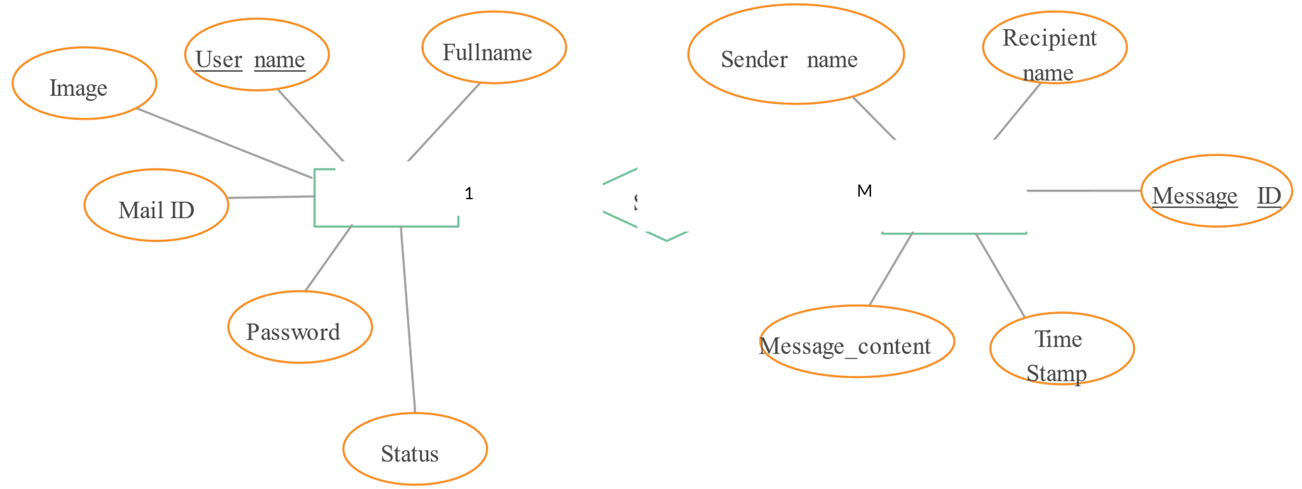

**CLASS DIAGRAM:**

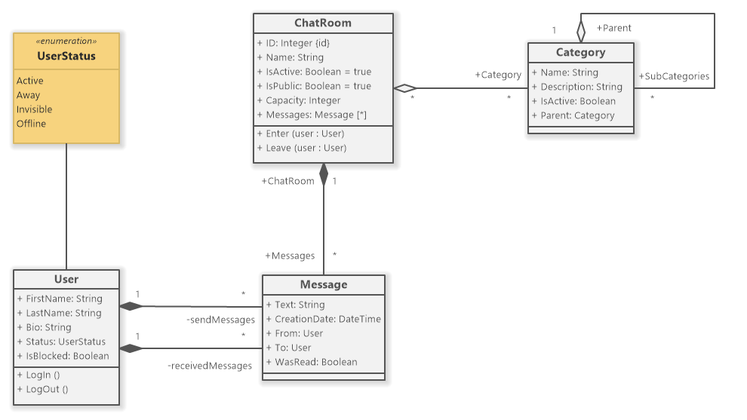

**USE CASE DIAGRAM:**

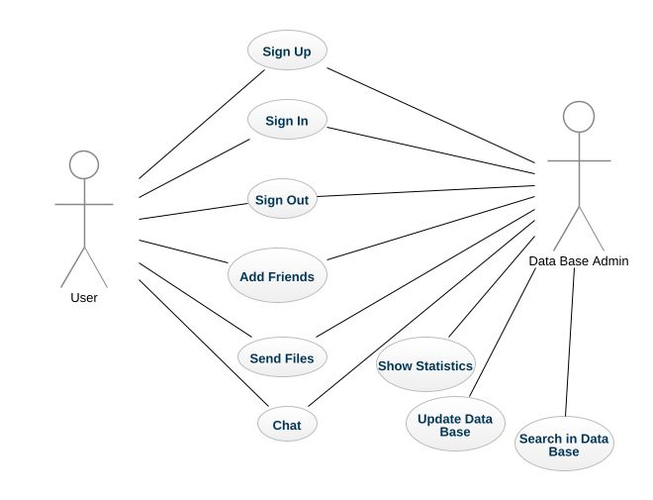

**SEQUENCE DIAGRAM:**

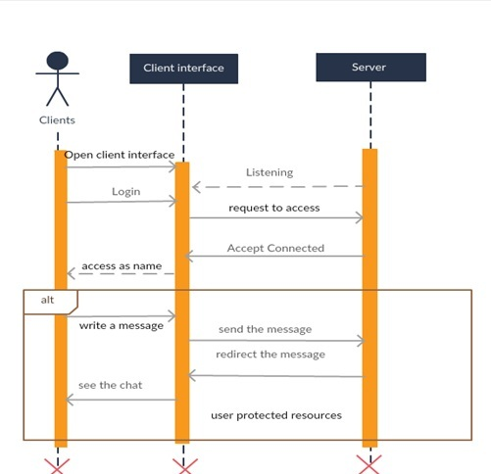

## **ACTIVITY DIAGRAM:**

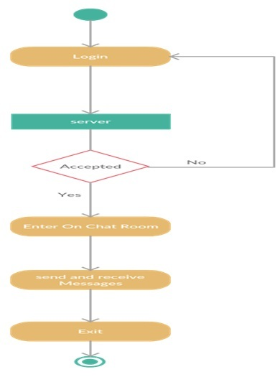

## **CONCLUSION AND FUTURE SCOPE**

**CONCLUSION:** In conclusion, the chat application provides a powerful and reliable platform for seamless communication in today’s fast-paced, interconnected world. With its user-friendly interface, real-time messaging capabilities, and secure environment, it addresses the growing need for instant connectivity across personal and professional networks. As digital communication continues to evolve, this chat application is well-positioned to meet future demands, offering a scalable, efficient, and engaging solution for users. The app’s flexibility and robust features ensure that it remains a valuable tool for enhancing collaboration, building relationships, and fostering meaningful interactions in an increasingly digital world.

**FUTURE SCOPE:**

The future scope of e-commerce nursery can be summarized in the following bullet points:

* + Increasing demand for real-time communication tools as people seek faster and more efficient ways to connect.
* Expansion of the global digital communication market, with chat applications becoming essential for both personal and professional interactions.
* Growing need for secure and private communication channels, leading to innovations in encryption and data protection.
* Rising adoption of remote work and virtual collaboration tools, driving the demand for reliable and feature-rich chat platforms**.**
* Advancements in technology such as enhanced data processing and real-time message synchronization, making chat applications more efficient and responsive for users.

**SNAPSHOTS:**

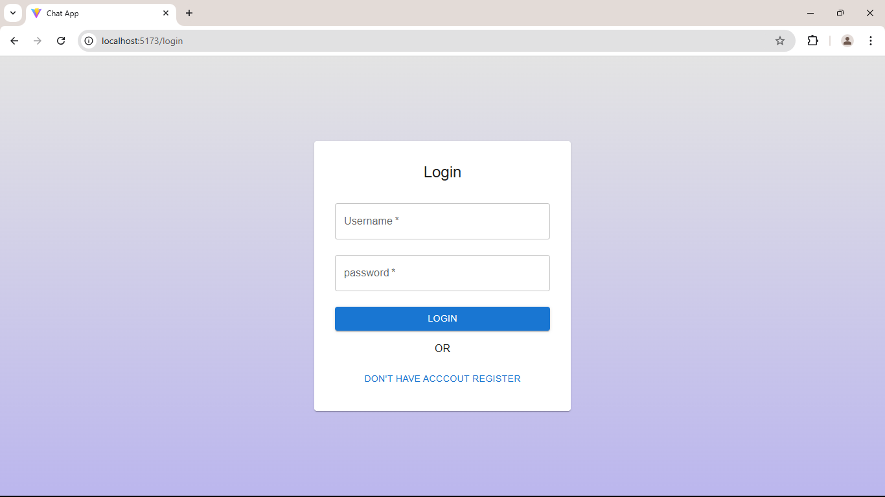

Figure : Home Page

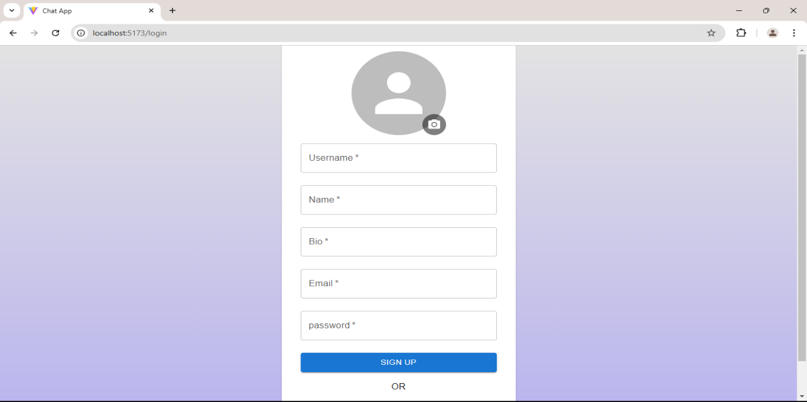

Figure New Products

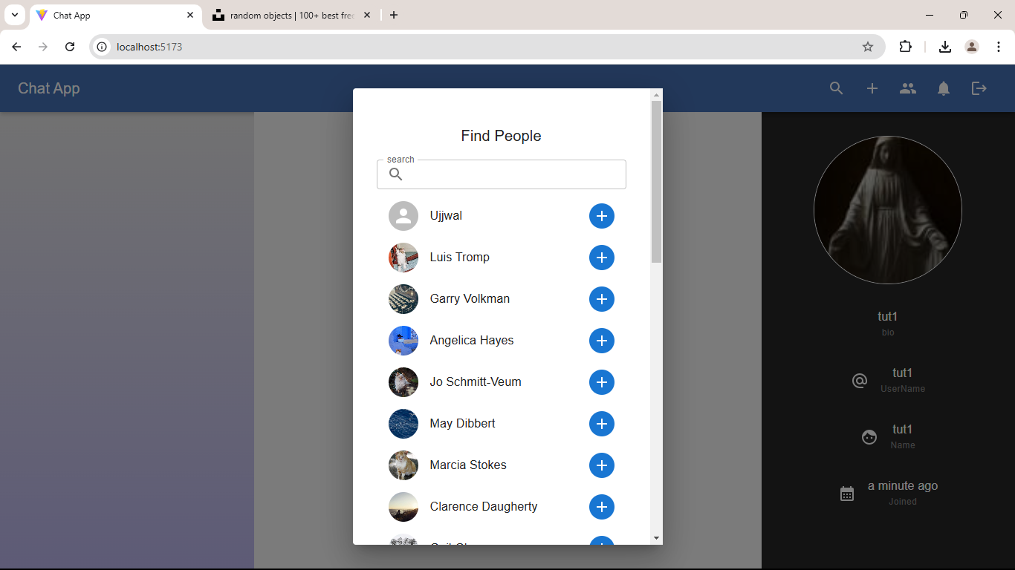

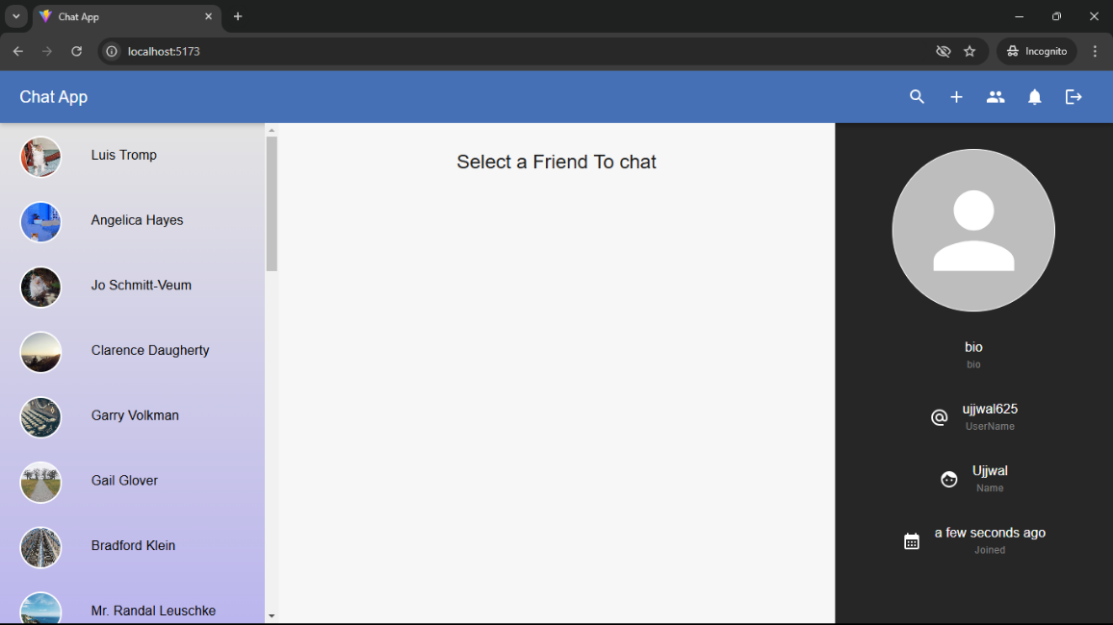

Figure Gallery

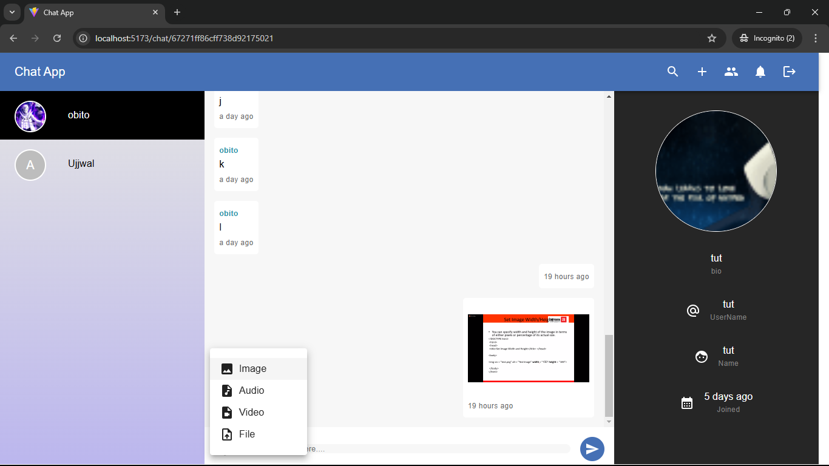

F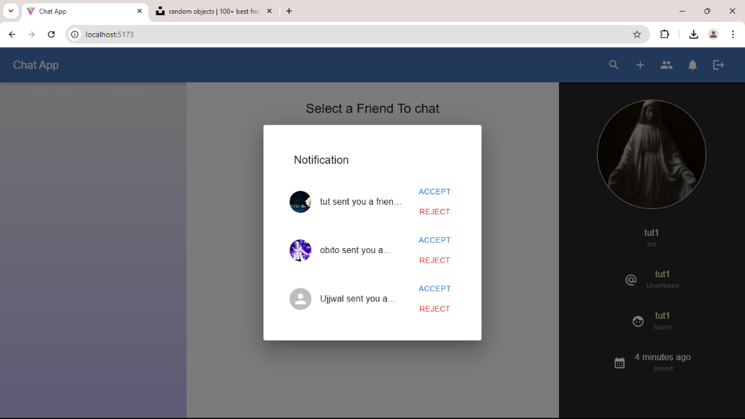igure Sign In

